7.52: For the skier to be moving at no more than 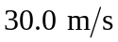; his kinetic energy at the bottom of the ramp can be no bigger than
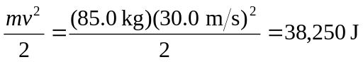
Friction does 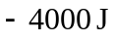 of work on him during his run, which means his combined PE and KE at the top of the ramp must be no more than 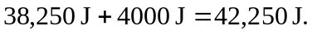 His KE at the top is
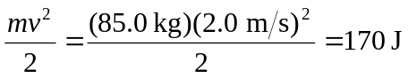
His PE at the top should thus be no more than 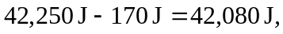 which gives a height above the bottom of the ramp of
